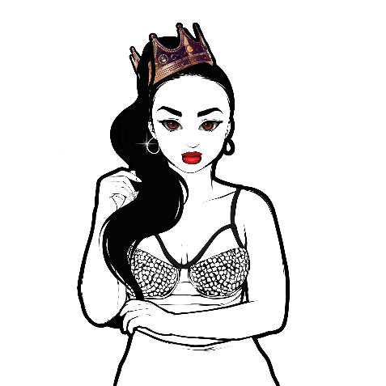

Non-Tech Rider
Billing and Publicity

All billing and publicity must read “Taija New”. Please include Taija New's website, www.TaijaNew.com, as well as social media handle, @TaijaNew, whenever possible. Approved Press and Publicity media can be found via this link authorized resources can be found here: http://www.taijanew.com/approved-press-and-publicity-media. Please only use the approved media this is provided on this page or contact Myles Sanders regarding any other approved media.

Hospitality

- Parking: Venue shall provide a secured parking area for Artist’s transportation. Area should be easily accessible to venue load-in doors, dressing rooms, and stage.

- Green Room: Room shall be clean, dry, heated and/or air conditioned with at least 1 ac outlet, makeup area, and mirrors. Please provide enough bottled water for 4 people with at least 1 bottle at room temperature. We would be grateful if hot water, individual tea bags, honey, AND stirrers were provided.

- Hotel: Artist and band members require one non-smoking hotel room that includes 2 full/queen size beds with corridor entrances (no outdoor motel like entrances).Hotel should be of a national chain such as: Marriott family, Hilton family, Holiday Inn or it's equivalent. Please ensure room is prepaid in full and reserved under "Taija Newton".

Merch Table/Meet and Greet
- 6 foot table (dressed) for merchandise and autographs (100% of sales goes to Taija New)

Other Requirements
- 4 hot meals or arrangements at a nearby restaurant

Contact: For press and publicity interviews or to answer any questions please contact Myles Sanders Phone: 413-222-1854 Email: booktaijanew@gmail.com

Buyer agrees to provide/adhere to the above-mentioned conditions/requirements.

Buyer Date

