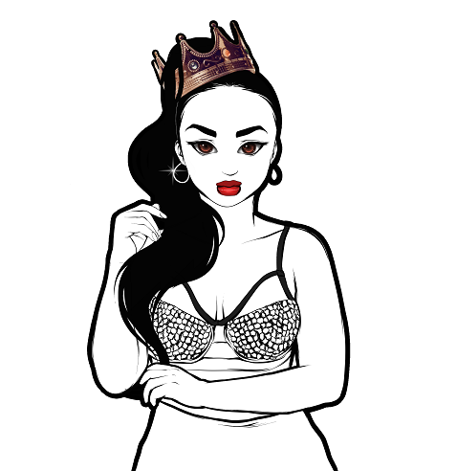
Taija New Artist Biography

Taija New, a.k.a. the Newbian King, is a Rhythmic Pop entertainer born and raised in Massachusetts. In 2015 New released her debut EP "Color Me Complex" which included her hit single "Newbian King" that also led to her very own Pandora station, Taija New Radio.
Her performances have been seen from across the U.S. to Canada where she has performed on the same stage as major acts such as: Jennifer Hudson, Todrick Hall, K.Michelle, Tiffany Evans, and Kirstin Maldonado from the Pentatonix.
In 2017 New released her highly anticipated sophomore album "Heart on the Stage" that was quickly followed up by her album-titled tour. Fresh off the release of her two singles "First Up on Your Last" as well as "Left 2 Right", Taija is currently completing her 3rd album and gearing up for her 3rd tour. For more information please visit www.taijanew.com.

